Analyzing Performance of FinTech Companies and the
Problems in FinTech Valuation

by

Siqi Zhang

An honors thesis submitted in partial fulfillment

of the requirements for the degree of

Bachelor of Science

Business and Economics Honors Program

NYU Shanghai

May 2020

Professor Marti G. Subrahmanyam Professor Ming Liao
Professor Christina Wang
Professor Jens Leth Hougaard

Faculty Advisers Thesis Adviser

Contents

1 Acknowledgments -------------------------------------------------------------------- 3
2 Introduction ---------------------------------------------------------------------------- 4
3 Perspectives and Critiques (Literature) ---------------------------------------- 5
4 Methodology and Interpretations ------------------------------------------------ 10
5 Conclusion ---------------------------------------------------------------------------- 16
6 Appendix ------------------------------------------------------------------------------ 17
7 References --------------------------------------------------------------------------- 20

Acknowledgements
I would like to show my gratitude towards my thesis supervisor, Professor Liao Ming, for his instructions and support about the data and the directions in my thesis.
I would like to thank Professor Marti Subrahmanyam for coordinating this program at NYU Shanghai and exposing us to many research insights in finance and other sectors. Thank you Professor Christina Wang and Professor Jens Leth Hougaard for your individual meeting and useful advice. In this spring semester, there must be a lot of difficulties for each online session. Thank you for making every seminar for us.
Additional thanks for Xinyi’s help on every Friday morning. Thank you for your hard work to keep contact with us and help the arrangement for each seminar. Thank you for your effort and help during this online spring semester.
Additional thanks to my classmates, especially my friend Yu Xu for your kind support.

Introduction
There has arisen a trend to see more and more FinTech startups. As the placement of the existing players is challenged, the incumbents like investment banks are incorporating more advanced algorithms in their services. Some even acquired FinTech startups to initiate their functions and improve their research and development in FinTech areas. Some detailed charts and data can be found in the appendix at the end of this paper to get a better understanding of the background of FinTech and its valuation.
The existing literature is closely examined in the next section. By learning the literature in both academics and in the industry, this paper attempts to demonstrate the potential problems and obstacles to the growth of a financial technology company by collecting and analyzing key information about some representative companies in the FinTech area in payment, banking, insurance, etc. As a common question in the FinTech industry, the valuation criteria will be examined to determine whether we should do the valuation using the similar method as we did for financial services companies. Therefore, the major issues to be addressed are the understanding of the performance and valuation measures and ratios. The main research questions explored in this paper are listed as follows. In valuation of FinTech startups, which valuation method do we use or are such companies treated more like financial services companies or technology companies? My classification model could give an answer for the research question above. FinTech companies are supposed to be evaluated as financial services companies, but in reality, most investors tend to treat them as tech companies because of the prospective high growth rate.
In order to get a better understanding of the role of FinTech and its significance, this paper provides some definition and clarification about some terms and “jargons” in this field. The word ‘FinTech” or Fintech, is a new word from both “financial” and “technology” that is used to describe a new trend in the financial services industry - utilizing new technologies and algorithms to innovate the functions of financial services such as mobile payment and robo-advisors. FinTech companies usually adopt some new business models, mathematical and programming algorithms like machine learning to improve the efficiency and lower the barriers for customers.
The rest of the research is structured in the following ways. This paper will first examine the existing academic literature on financial technology and its performance and valuation methods. Critical responses and critiques towards those analysis and perspectives will also be incorporated. Next, this paper will clarify the data sources and format for the modeling. After that, it will closely examine the results of the logistic regression models and other models in terms of their accuracy and other measures. Finally, this paper will give some conclusion and interpretation for financial technology in terms of the valuation problems, possible challenges, and potential benefits for successful performances.

Perspectives and Critiques
This part will analyze the existing literature and bring some of my responses and critiques to perspectives and findings specific to the FinTech area. This paper has explored some research in the valuation of the FinTech industry and what the potential risk that startup might face in the beginning stage. There is also some academic research about VC investments and their performance in relation to the FinTech companies. Some papers analyze the various investment strategies, recommendation systems in venture finance, data-analytics to improve performance of the portfolio.
To begin with, some academics provide a general discussion of FinTech functions and research directions. Gomber, Peter, et al [9] illustrated the impacts of financial technology or digital finance and also listed some directions for future research. They examined mainly six digital finance functions and the impacts of technology to services. Nicoletti, Bernardo [12] wrote a relatively comprehensive book on the topic of FinTech including models, innovations, critical successful drivers, response of existing players, and regulations. Varga, Dávid [16] provided a detailed definition of fintech and researched the regulatory and value-added parts. This study explored a global perspective about fintech innovation and the impacts to disadvantaged groups of people.
We can see a trend of more and more machine learning algorithms used in both FinTech companies and its investors (venture capitalists). Arroyo, Javier, et al. [1] explored several machine learning approaches that could be implemented in the venture capital investments. They confirmed the significance of machine learning in the improvement of portfolio management. They also made clear that such kind of analysis is possible given the large amount of data of private companies in platforms such as CrunchBase. Their research not only predicted the two exit ways like being acquired or going IPO, but also included the situations like going into the subsequent funding round or other exit ways that are beneficial to the venture capitalists. They claimed that by doing this, their models could give more information to investors about their portfolio management in order to get a more sustainable and less risky returns. However, I think their approach still has potential problems. As the authors preferred a portfolio with lower risk, this may be contradictory to some venture capitalists that want high returns (high risks). Besides, as they classified subsequent funding as one of the criteria for success, this may be because the company is burning the money of investors in either marketing campaigns or other customer acquisition processes. In certain circumstances, such money-burning operations may be inefficient and receive few profitable outcomes. Without specific constraints on the effectiveness measures, it is difficult to give practical advice for investors. What’s more, as FinTech is a new industry, specific concerns need to be addressed. Estrin, Saul, et al [7] examined the marketplace of equity crowd funding in the UK and some implications for investors and policymakers (regulators). Similar questions also appear in Chinese market.
When referring to the FinTech industry, some sectors can be divided such as P2P lending, investment (robo-advisors), insurance, payment, etc. They are classified based on the characteristics of their services instead of the technology that they actually implemented. Buchak, Greg, et al [2] gave an analysis of the effect of regulation arbitrage and technology benefits to the rising of FinTech companies in the lending sectors. One of the significance of their study is the quantification of the growth contributed by regulation arbitrage and technology advancement, with 60% and 30% respectively.
As for wealth management services, D’Acunto, Francesco, et al [5] researched robo-advisors and stated the significance of its diversification benefits for investors. However, some claims in this research are ambiguous such as the claim of both better returns and less volatility. Though their identification of the promises of robo-advisors is not persuasive, they still provide some reasonable pitfalls of robo-advising tools. As they stated, both trend chasing and rank effects have certain bias when balancing the portfolio. If they could give some solutions or even some proposals to solve those biases such as some regulation or constraints in the algorithms, then this research would have more influence for robo-advisors and even to the broader FinTech area.
As for the area of payment, Klein, Aaron [11] gave a detailed illustration about Chinese mobile payment transformation and development. A lot of FinTech elements can be seen in this paper such as the QR codes, digital wallet, payment ecosystem and regulation, adoption in other areas, etc. Klein made several arguments and predictions regarding the payment system in both China and in the US. He pointed out the vital challenges brought to banks since mobile payment will inevitably disintermediate big banks. Such a system is more likely to be adopted in other emerging markets rather than the US market. As the inequality remains a huge issue, wealthier customers with more benefits from the existing system are reluctant to accept the new payment system. It is also difficult for both merchants and customers to transition to the new way of payment. Corresponding regulation and protection rules are not well developed for the change to mobile payment (without a traditional bank). To, Wai Ming, and Linda S. L. Lai [15] also demonstrated users’ perspectives, opportunities, and barriers in the mobile banking and payment mainly in the Chinese market.
The valuation is also a significant issue for both FinTech startups and investors. Damodaran, Aswath [6] give an outline and some guidelines for valuation that could also be applied to FinTech companies. As for young companies like fintech startups, Damodaran argued that regression betas cannot be used and cost of capital will also be changing. We can also notice that free cash flows of the company are always negative even though the company is making money. He also advised to capitalize some operating expenses because these expenses could generate future growth. As the information is changing quickly for such companies, it is difficult to have a correct valuation number. He gave the example of Amazon at an early stage and Goldman Sachs to illustrate the valuation adjustment of young firms and financial services companies respectively. For financial services companies, it is extremely difficult to get accurate information about the cash flows and the quality of their assets. It is also important to use the dividend discount model and take the book value into consideration because regulators would use ratios reflected by book value. To most parts, I agree with what he stated about the valuation; similar concerns can also be addressed in the FinTech companies. As in the later modeling sections, some interpretation of my models will also echo part of the claims in this study.
However, not all research agreed with the valuation methods adopted by venture capitalists. There are other perspectives that take a careful consideration about the valuation problems. Gornall, Will, and Ilya A. Strebulaev [10] closely analyzed the venture capital backed companies and tested the methods to unicorns (companies with valuation more than 1 billion US dollars). After making adjustments about the values of shares for each investor class, their calculated valuations turned out to be much lower than the original valuation numbers. Though this adjustment seemed persuasive under its assumptions, it is still difficult to decide whether we should treat FinTech companies more like financial services companies or more like the technology firms. My modeling approach will also give another attempt and perspective regarding the valuation concerns about FinTech companies.

Methodology and Interpretations
Methodology consists of both quantatitive and qualitative analysis. Qualitative analysis include some interviews with venture capitalists and startup founders in FinTech industry. Quantative research include a logistic regression model and other machine learning models used for classification. This section will first introduce the data and quantatitive model results, then closely analyze the interpretation for FinTech performance and valuation from both the qualitative and quantatitive research.
For data about public companies, relevant data is collected from the annual reports about companies, Thomson One, Capital IQ, and Bloomberg. As for data of private companies and some general data about the market trend, data is collected from Pitchbook, Crunchbase, CB Insights, and Mintel. The data mainly consists of some financial services companies, technology companies, FinTech companies and their financial ratios respetively. As the accurate data about private firms is difficult to obtain and many existing data on those data platforms lagged a lot, this dataset contains mainly data of public companies. A copy of some data used can be found in the appendix section at the end.
Typical financial services includes banks, insurance companies, investment service companies, funds, exchanges companies, etc. While technology companies usually include interactive media, information technology, communication service, etc. Potential predictors are ROE (return on equity), growth (total revenue growth over prior year), and margin (net income margin). ROE is a ratio of net income to equity (expressed as a percentage in my data). It is used to measure the return on equity and “how effectively management is using a company’s assets to create profits”. ROE is also an approximate measure of growth for a company (as growth rate = ROE (1-k)). Revenue growth (expressed as a percentage) over prior year could indicate how the revenue grows (or declines) and whether the company develops well. Net income margin (or net profit margin) is net income / total revenue (expressed as a percentage). As it is in percentage rather than dollar amount, this could be used to measure the profitability of the business regardless of the size.
As for the predictors, a hypothesis is that tech companies would have higher ROE and higher growth rate, as they tend to grow quickly because they could take advantage of their technology and network effects. There is no definite answer about margin as business may vary a lot even in the same industry group. While, lower ROE or lower growth may point to a financial company as they are more capital intensive because banks have to meet certain capital requirement. They also have lower growth, as this industry seems to have less innovation than tech. ROE and growth show separation between Fin and Tech companies as we expect to see. It seems that it’s hard to predict Fin or Tech by looking at margin of the company. These are some initial hypothesis before seeing the actual model results. Next, some results of the model will be displayed. After that, a detailed interpretation of those numbers will be given.

Method
Link function | Logit
Residuals for diagnostics | Pearson

Deviance Table
Source | DF | Adj Dev | Adj Mean | Chi-Square | P-Value
Regression | 3 | 22.347 | 7.4491 | 22.35 | 0.000
ROE% | 1 | 12.544 | 12.5443 | 12.54 | 0.000
Margin% | 1 | 2.672 | 2.6722 | 2.67 | 0.102
Growth% | 1 | 20.131 | 20.1314 | 20.13 | 0.000
Error | 26 | 19.242 | 0.7401

Model Summary
Deviance  R-Sq | Deviance  R-Sq(adj) | AIC
53.73% | 46.52% | 27.24

Coefficients
Term | Coef | SE Coef | VIF
Constant | 3.30 | 1.51
ROE% | -0.259 | 0.118 | 5.59
Margin% | 0.1132 | 0.0858 | 2.74
Growth% | -0.2009 | 0.0723 | 2.93

Odds Ratios for Continuous Predictors
 | Odds Ratio | 95% CI
ROE% | 0.7719 | (0.6121, 0.9734)
Margin% | 1.1198 | (0.9466, 1.3248)
Growth% | 0.8180 | (0.7098, 0.9426)

Goodness-of-Fit Tests
Test | DF | Chi-Square | P-Value
Deviance | 26 | 19.24 | 0.826
Pearson | 26 | 20.57 | 0.764
Hosmer-Lemeshow | 8 | 4.45 | 0.814

Measures of Association
Pairs | Number | Percent | Summary Measures | Value
Concordant | 211 | 93.8 | Somers’ D | 0.88
Discordant | 14 | 6.2 | Goodman-Kruskal Gamma | 0.88
Ties | 0 | 0.0 | Kendall’s Tau-a | 0.45
Total | 225 | 100.0
Association is between the response variable and predicted probabilities

Hosmer-Lemeshow test has large p-value indicating a good fit to data. Somers’ D is high which shows a good separation between financial services and technology firms with 93.8% concordant pairs and 6.2% discordant pairs. Overall regression is statistically significant. Coefficient of margin is moderately statistically significant with p-value = 0.102, while coefficients of ROE and growth are very significant with p-value < 0.001. ROE coefficient implies that a one percentage point increase in ROE is associated with an estimated 23% decrease in the odds of a firm being financial service firms, given growth and margin are held fixed. Margin coefficient implies that a one percentage point increase in margin is associated with an estimated 12% increase in the odds of a firm being financial service firms, given all else are held fixed. Growth coefficient implies that a one percentage point increase in growth is associated with an estimated 18% decrease in the odds of a firm being financial service firms, given all else are held fixed.
Residual plots and diagnostics indicate an outlier Cisco. It has a negative growth rate (2.5%) which means that its revenue in 2017 declines 2.5% compared to 2016. In its annual report, Cisco reported “revenue declines for product streams including network switches, routing, data center and collaboration”. We also have one leverage point Tesla. Tesla has negative ROE(-38.8%) and negative margin (-16.7%), but very high growth (68%). This is because that Tesla is still a relatively young company in an explosive growth condition. Also, Tesla’s priority is growth which is reflected in the high growth number.

Tabulated Statistics: response, Predict Cell Contents: Count % of Total
Rows: response Columns: Predict
 | 0 | 1 | All
0 | 12 | 1 | 13
 | 44.44 | 3.70 | 48.15
1 | 1 | 13 | 14
 | 3.70 | 48.15 | 51.85
All | 13 | 14 | 27
 | 48.15 | 51.85 | 100.00

A classification table for this fitting is given above. 25 of 27, or 92.6%, of the firms were correctly classified, far higher than Cpro = 62.6% and Cmax= 51.85%, reinforcing the strength of the logistic regression. The outliers would have been misclassified, so the actual correct classification rate is 83.3%. As this is a retrospective study, the estimated probabilities of financial services companies are not appropriate for prospective modeling, but prospective probabilities can be obtained by adjusting the constant term of the regression. A 62% Fin prior probability is used because I find under the constituents of the two-industry group and find 6089 companies under information technology and 10000 companies under financials.
Some other classification models are also tested on the same data, but it seemed that a simple model like the above could do a good job as the other machine learning models did. From this model, the result confirmed my aforementioned response and critiques towards the valuation problems and concerns mentioned by Gornall [10] and Damodaran [6].
Besides the above classification model results, some qualitative analysis is also conducted. As FinTech includes a lot of sectors, this paper will analyze mainly the payment and robo-advisors (wealth management tech) as the focus. Other segments in FinTech share similar opportunities and challenges and could get some implications from the analysis as well.
The performance of payment and the increasing need for payment is driven by the booming e-commerce and other digital developments. Customers’ demand for seamless experiences and merchants’ demand for lower transaction fees also contribute to the rise of more and more real-time payment platforms. By 2019, the market for payment had estimation by PitchBook of 1.2 trillion dollars. The market still has a lot of space to be explored including the transaction volume, hardware for merchants, data platforms, and software for B2B incumbents. The Chinese mobile payment model is a possible direction for future development as the Omni payment systems have great potential to integrate various functions, thus decreasing fees and enhancing customer experiences. However, there are significant challenges, as seen in the evidence from company failures and barriers for entrance, from low margin due to the lower transaction costs, competitive pressure from the incumbent players, security and privacy concerns of customers.

Conclusion
In conclusion, FinTech receives significant attention from both the emerging startups and investors. Real-time, integration, regulations benefits, efficient algorithms are the drivers in this industry. Additional considerations should be given to the actual implementation of technology and the protection of user data and privacy. The problems in valuation reflected the overall overheated investment in AI technology. Due to the special characteristics of financial services industry, such valuation method and strategy taken by the investors should be give a second thought before finalization. FinTech companies should improve their risk management functions and minimize the external risks from both the regulatory changes and technological lagging adoption.

Appendix

Figure 1 FinTech total capital raised and fund count (2009 – 2020)
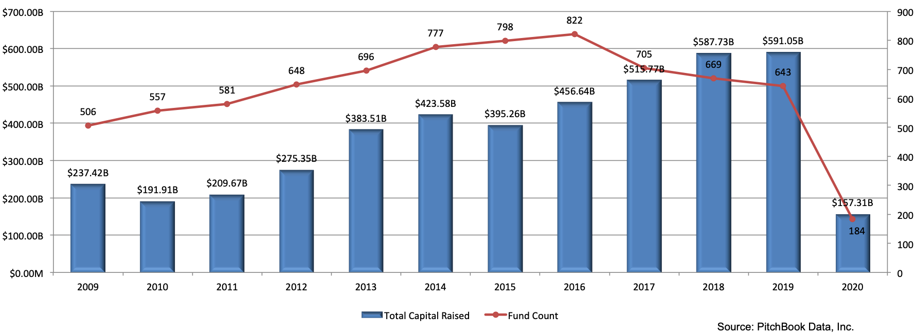

Figure 2 FinTech median post valuation and deal size (2011 – 2020)
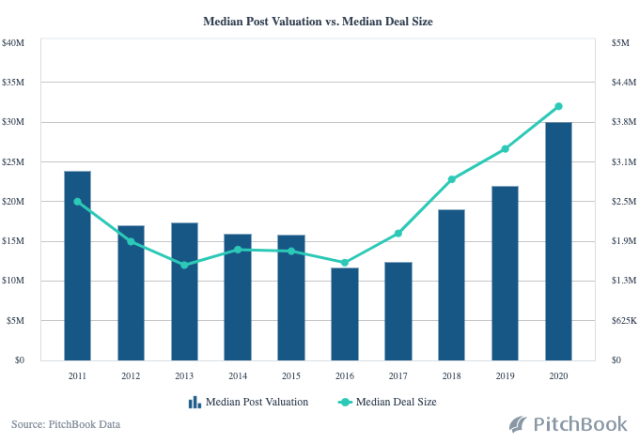

Figure 3 company deals and valuation: financial services and information technology (2000-2020)
 | Financial Services |  |  |  | Information Technology
 | Deal Count | Capital Invested | Pre-money Valuation Sum | Post Valuation Sum | Deal Count | Capital Invested | Pre-money Valuation Sum | Post Valuation Sum
Year
2020 | 133 | 25,380.47 | 769.63 | 17,672.05 | 456 | 22,320.58 | 29,592.84 | 52,491.70
2019 | 1,116 | 126,147.66 | 53,978.75 | 184,611.96 | 3,132 | 99,341.75 | 173,510.86 | 263,620.85
2018 | 1,183 | 104,369.36 | 74,240.19 | 233,119.89 | 3,839 | 129,931.81 | 314,247.28 | 518,288.77
2017 | 989 | 41,033.50 | 36,320.60 | 79,843.62 | 3,283 | 58,497.38 | 52,216.07 | 204,163.45
2016 | 902 | 54,762.05 | 32,096.16 | 80,372.51 | 2,648 | 52,792.15 | 97,676.95 | 159,123.67
2015 | 883 | 53,109.16 | 38,941.96 | 107,919.86 | 2,273 | 64,204.89 | 105,553.87 | 349,187.60
2014 | 639 | 30,580.67 | 10,459.49 | 68,764.08 | 1,665 | 37,173.53 | 41,609.58 | 76,111.48
2013 | 428 | 23,831.62 | 10,824.24 | 67,873.75 | 1,159 | 19,915.47 | 11,282.72 | 36,790.99
2012 | 281 | 7,853.16 | 8,840.90 | 22,301.86 | 795 | 14,238.52 | 18,201.21 | 33,141.24
2011 | 235 | 20,118.41 | 595.75 | 23,000.42 | 572 | 11,635.77 | 7,191.62 | 24,057.47
2010 | 188 | 8,156.55 | 11,089.07 | 22,728.08 | 422 | 27,516.06 | 6,308.33 | 34,197.07
2009 | 130 | 3,894.32 | 1,050.81 | 10,277.61 | 289 | 4,215.28 | 1,323.78 | 5,002.25
2008 | 170 | 41,783.70 | 24,982.03 | 76,418.96 | 293 | 5,302.66 | 1,349.28 | 7,063.99
2007 | 175 | 20,802.20 | 11,592.81 | 38,360.63 | 302 | 36,495.17 | 4,381.22 | 40,140.12
2006 | 101 | 5,750.91 | 8,985.55 | 18,298.41 | 216 | 7,601.41 | 819.67 | 7,275.36
2005 | 89 | 5,602.05 | 10,726.61 | 20,262.30 | 163 | 19,742.81 | 914.87 | 30,198.57
2004 | 74 | 18,227.57 | 1,800.72 | 24,518.19 | 126 | 4,020.53 | 676.51 | 5,022.75
2003 | 58 | 4,092.95 | 3,021.22 | 7,405.40 | 112 | 797.59 | 360.14 | 1,261.17
2002 | 48 | 2,342.19 | 23.36 | 4,569.15 | 123 | 2,545.52 | 1,272.66 | 3,539.93
2001 | 58 | 26,577.70 | 249.85 | 24,154.58 | 111 | 1,658.98 | 466.92 | 2,377.84
2000 | 68 | 4,269.45 | 8,829.65 | 14,267.42 | 167 | 6,458.65 | 1,624.55 | 7,344.73
All | 7,948 | 628,685.65 | 349,419.35 | 1,146,740.73 | 22,146 | 626,406.51 | 870,580.93 | 1,860,401.00

Figure 4 2019 Q4 FinTech investments : companies and amount raised

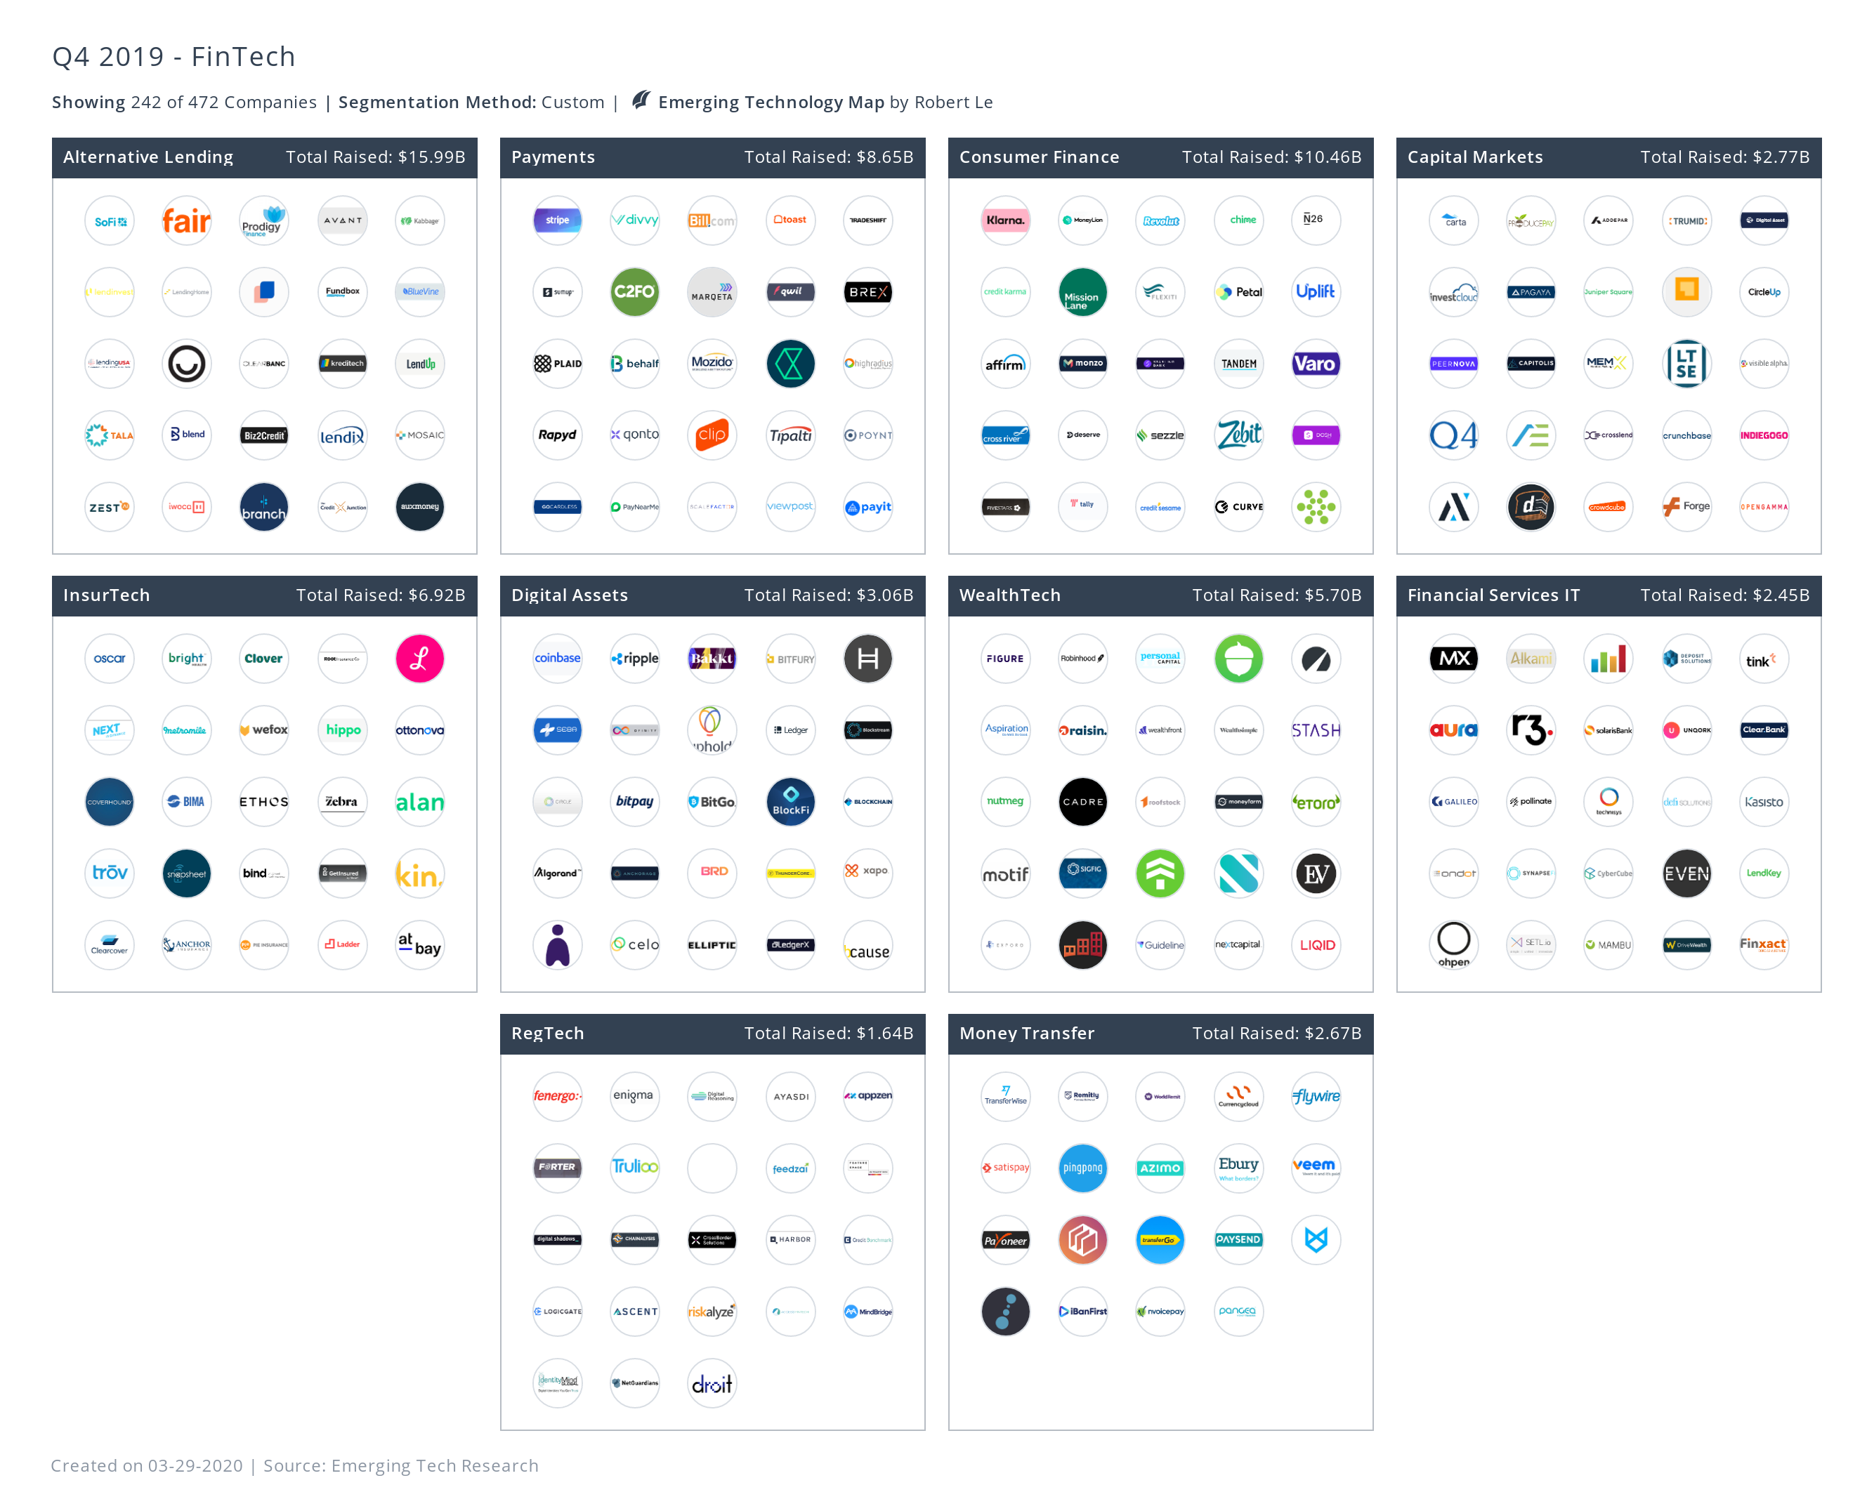

References
[1] Arroyo, Javier, et al. “Assessment of Machine Learning Performance for Decision Support in Venture Capital Investments.” IEEE Access, vol. 7, 2019, pp. 124233–43.
[2] Buchak, Greg, et al. “Fintech, Regulatory Arbitrage, and the Rise of Shadow Banks.” Journal of Financial Economics, vol. 130, no. 3, Elsevier B.V., 2018, pp. 453–83.
[3] Davenport, T.H., Barth, P., and Bean, R., "How big data is different", MIT Sloan Management Review, 54(1), 2012, pp. 43.
[4] Duan, Y., and Cao, G., "Understanding the Impact of Business Analytics on Innovation", Proceedings of the 23rd European Conference on Information Systems, 2015, pp. 1- 16.
[5] D’Acunto, Francesco, et al. “The Promises and Pitfalls of Robo-Advising.” The Review of Financial Studies, vol. 32, no. 5, May 2019, pp. 1983–2020.
[6] Damodaran, Aswath. The Dark Side of Valuation : A Jedi Guide to Valuing Difficult-to-Value Companies. pp. 1–98.
[7] Estrin, Saul, et al. “The Evolution and Adoption of Equity Crowdfunding: Entrepreneur and Investor Entry into a New Market.” Small Business Economics, vol. 51, no. 2, Springer New York LLC, Aug. 2018, pp. 425–39.
[8] Gomber, Peter, et al. “On the Fintech Revolution: Interpreting the Forces of Innovation, Disruption, and Transformation in Financial Services.” Journal of Management Information Systems, vol. 35, no. 1, Routledge, Jan. 2018, pp. 220–65.
[9] Gomber, Peter, et al. “Digital Finance and FinTech: Current Research and Future Research Directions.” Journal of Business Economics, vol. 87, no. 5, Springer Berlin Heidelberg, July 2017, pp. 537–80.
[10] Gornall, Will, and Ilya A. Strebulaev. “Squaring Venture Capital Valuations with Reality.” SSRN Electronic Journal, vol. 1, no. 604, 2018, pp. 1–54.
[11] Klein, Aaron. “Is China’s New Payment System the Future.” Brookings Institution, June, Online at Http://Www. Brookings. Edu/Wp-Content/Iploads/2019/05/ES_20190617_Klein_ChinaPayments. Pdf, no. June, 2019, https://www.brookings.edu/wp-content/uploads/2019/06/ES_20190617_Klein_ChinaPayments.pdf.
[12] Nicoletti, Bernardo. Palgrave Studies in Financial Services Technology Integrating Finance and Technology in Financial Services The Future of FinTech. http://www.springer.com/series/14627. Accessed 22 Oct. 2019.
[13] Pathak, Nishith, and Nishith Pathak. “The Future of AI.” Artificial Intelligence for .NET: Speech, Language, and Search, 2017.
[14] Stone, T., Zhang, W., and Zhao, X., "An empirical study of top-n recommendation for venture finance", Proceedings of the 22nd ACM international conference on information & knowledge management, 2013, pp. 1865-1868.
[15] To, Wai Ming, and Linda S. L. Lai. “Mobile Banking and Payment in China.” IT Professional, vol. 16, no. 3, IEEE Computer Society, 2014, pp. 22–27.
[16] Varga, Dávid. “Fintech, the New Era of Financial Services.” Vezetéstudomány / Budapest Management Review, vol. 48, no. 11, Corvinus University of Budapest, Nov. 2017, pp. 22–32.
[17] Weibl, Johannes, and Thomas Hess. “Finding the Next Unicorn: When Big Data Meets Venture Capital.” Proceedings of the 52nd Hawaii International Conference on System Sciences, vol. 6, 2019, pp. 1075–84.
[18] Xu, R., Chen, H., and Zhao, L.J., "Predicting Corporate Venture Capital Investment", Proceedings of the 38th International Conference on Information Systems, 2017, pp. 1-10.

